**Minutes of OUWG’s AGM Meeting**

**23rd September 2020, 7:30 – 9:30pm**

**Zoom Virtual Meeting**

## Attendees

* Chair: Helen Edwards and Candida March
* Trustees present: Patricia Mansfield, Jon Willis, James Winder, Phil Dines, Pete Byfield, Karen Salter
* Members and guests present: Jane Miller, Christine Cowley, Nadia Rich, Ed Munday, Liz Hodgson, Andy Gunn, Bill Frizzell, Carl Whitehead, Ed Munday, Eliane Aubain, Jude Mann, Alex Stonor, Payam Mohaghegh, Ali Jones, Jon Hyslop
* Apologies: Pascale Nicolet, Louise Evans, Margarite Willis, Sarah, Richard Newton, Lucy Ingrams
* Minutes: D’Aundre Ryan

## Minutes

The minutes from the previous meeting (15th July 2020) were passed.

## Chair’s Report

**Our 5-year Vison**

In this plan we strive to create a great range of opportunities for wildlife to flourish within BBNP. We hope to achieve this through providing a mosaic comprised of 3 types of habitat across the site in roughly equal coverage:

* 1/3 of the site will be cut every 1-3 years to maintain the kind of rough grassland.
* 1/3 be managed as coppice woodland, and scrub – including hawthorn, blackthorn and bramble
* 1/3 will be grown into mature woodland – including the original woodland site and selected areas where a high canopy will not adversely affect neighbouring landowners.

**A Year in Review – Notable Highlights**

**Pond** – Relined and ready to be built back up to a mature freshwater margin habitat. Many local volunteers came out to help us achieve this, we cannot thank you all enough.

**BBOWT –** OUWG has been working in collaboration with BBOWT to provide training workshops to all our members in the community who are interested in gaining conservation management skills. Throughout our seasonal work plans, they have helped to organise and run regular work parties for coppicing and hedge-laying.

**TOE Grant Application –** To further support our work in the coming year, we have recently put in a grant application to the Trust for Oxfordshire Environment (TOE) – This will be for our Pond, Glades and Woodland project 2021. There will be an on-site assessment in early October. This funding would greatly help us

**Freshwater Habitats** - of advice in redesigning the lined pond, relining and reprofiling the pond in our wildlife garden and in planning our pond management over the next year under the TOE bid.

**Earth watch –** Naturehood Programme at BBNP and we hope that will continue into the future.

**Oxford Brookes –** Each year students are offered the opportunity to work with us as part of their environmental consultancy module each year. Last year they produced a plan on developing ground flora diversity in the coppiced woodland for us. This year we hoping to put forward a project to develop a mammal survey.

**Ecotherapy Oxford –** Helped launch an ecotherapy project in our very own Wildlife Garden. Their advice in getting this project up and going has been invaluable. They offer simple practises working outdoors with people seeking support, run a peer supervision group and offer individual mentoring to practitioners wanting to work outdoors.

**Apple Tree –** Our site will be used by a group of members focusing on developing toddlers in with nature, experiencing the beauty and value of nature from a young age.

**Freshwater Habitats –** Freshwater Habitats have been a valuable source of advice in redesigning the lined pond, relining and reprofiling the pond in our wildlife garden and also in planning our pond management over the next year under the TOE bid.

**Working with Schools -** Involving schools more meaningful engagement with the site and promoting stewardship for wildlife in our next generations.

**Future Goals for OUWG:**

* **Developing community engagement through social media and newsletters**
* **Focus on carbon management**
* **Working towards Green Flag community award**
* **Develop fundraising**
* **Renew lease**
* **Changing**

## Treasurer’s Report

OUWG received £500 grant for the development of the wildlife garden, which has been put to good bringing the garden back to life.

This year we have had 2 significant expenses covered by the treasury.

This includes:

* £470 due to the pipe leak resulting in a water loss charge.
* £700 used to buy plants and shrubbery for the site

The inventory of machinery will be complete and ready for next year.

**Decision**: Trustees and members have approved the treasurers report [1].

## Membership Secretary’s Report

We have a total of 135 which is great news (100 paying members/ 35 pending payment)

All new members will receive a welcome email which will include pins for access to the site. Membership renewal will be due 12 Months from the date you become a member.

## Election of Trustees Nominations

• Chair Helen Edwards – **Re-elected**

• Secretary D'Aundre Ryan – **Re-elected**

• Treasurer Jon Willis – **Re-elected**

• Membership Secretary Karen Salter – **Re-elected**

• James Winder

• Pat Mansfield

• Nadia Rich – **Elected**

• Pete Byfield

• Trustee from Young Trustee Scheme

**Action/Decision**: New trustees elected, and existing trustees re-elected to reprise roles.

**Active members**

• Phil Dines (Manages our website)

• Candy March

## AOB

Head teacher at Larkrise interested in re-wilding parts of the site for outdoor education in nature. They would love to collaborate on effort to support us in any way possible. We look forward to this.

Cheney School would like to collarorate on a tree project with BBNP.

The Greater water parsnips reintroduced last week to BBNP; we now been added as a species conservation site.

## Questions from the floor

## Final Statement from our Chair

“This has been a busy, productive year. The group has strengthened with renewed commitment to a shared vision. The park is more accessible with a peaceful yet wild atmosphere, teeming with wildlife, and we have seasonal plans for continuation of restorative and maintenance work. We hope to extend our ecological surveying, monitoring activities and continue to improve biodiversity. We will be keeping an eye on water levels whilst exploring the balance of wildlife habitats, grassland, scrub areas, woodland canopy and pond catchment areas as we restore our freshwater margins and groundwater ponds. We hope you will continue to help OUWG flourish in its commitment to maintain the wildlife interest of this important nature park and maintain the delicate mosaic of wildlife habitats of Boundary Brook Nature Park for enjoyment by all. Thank you.” – Helen Edwards

## Thank You All

We would like to thank everyone that has given their time and efforts to BBNP supporting us in our continued growth on-site and within the local community.

This includes:

East Ward Allotments

Oxford City Council

BBOWT.

All our members

Visitors of the site

Every work party volunteers

Those who have provided us key advice on all our projects

A special thank you to all our trustees within OUWG, both past and present. It is your continued passion for wildlife conservation and the love of our site, that is the driving force to achieve our management plan goals.

We look forward coming year with strength and support from you all on our shared journey. It has been a pleasure, stay safe and see you all very soon.

## Appendix

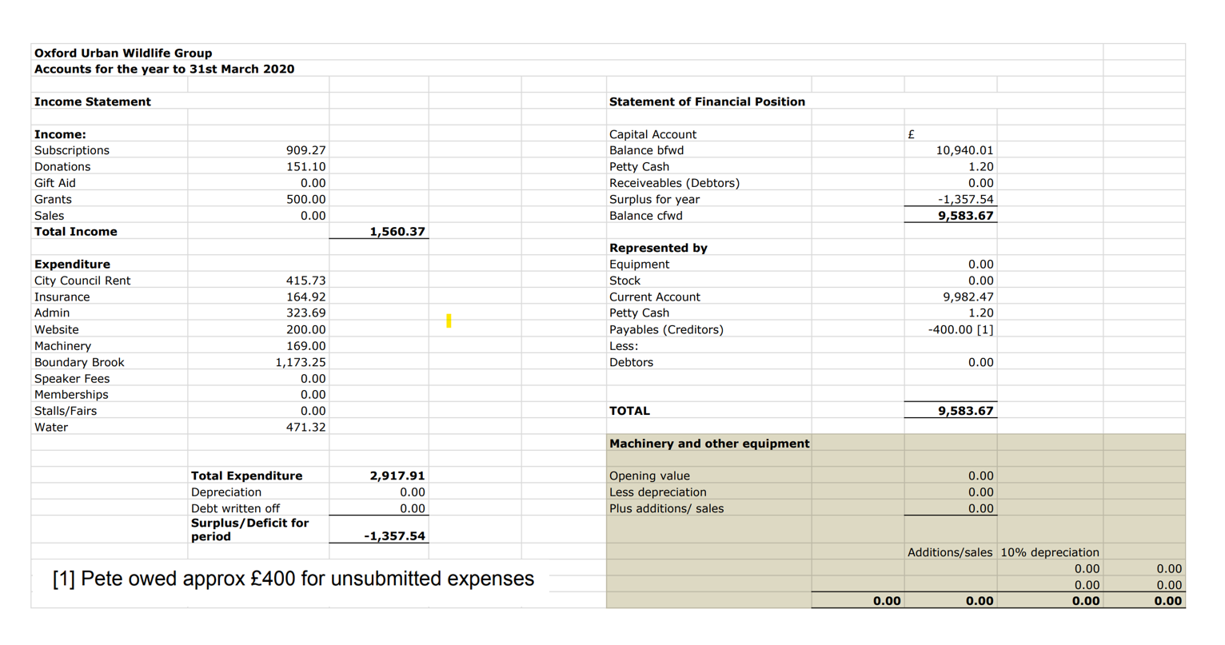

[End]

1. Treasurers report can be found in the appendix